**Module -7 Assignment**

**Q1.) Build a simple webpage that displays text as shown in the below image.**

**Output-**

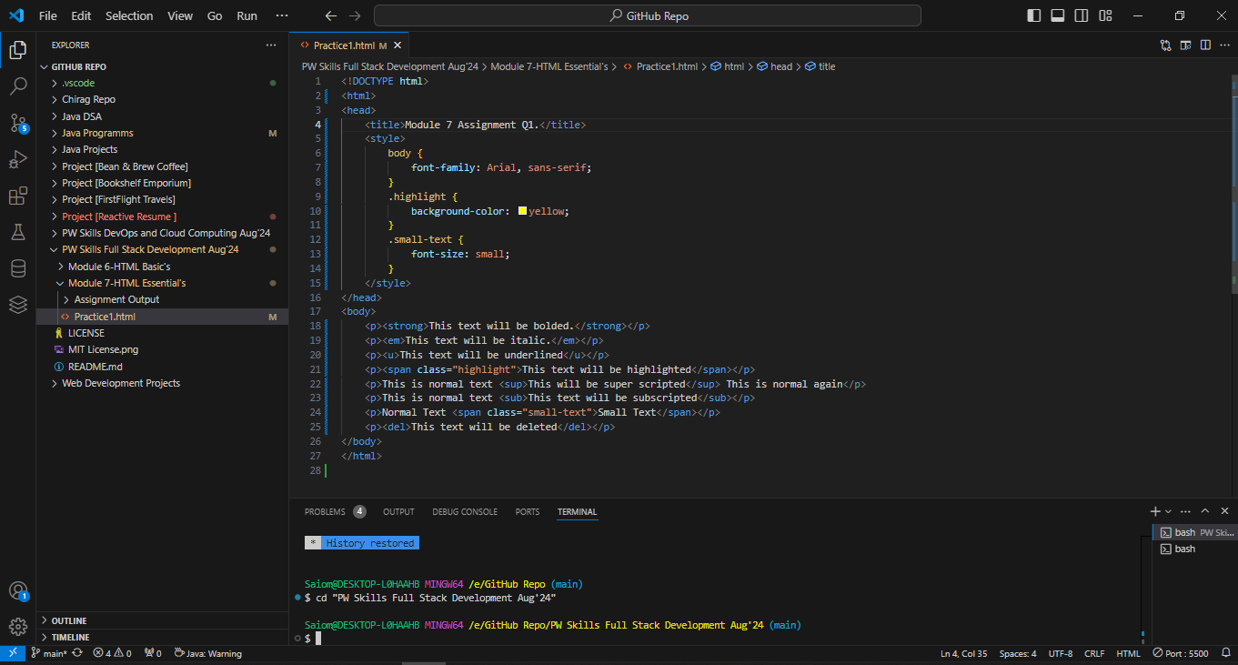

**Q2.) Build a simple webpage that helps users navigate different web development-related websites. Note: On clicking the hyperlink, the web pages should open in a new tab. Below is a reference image.**

**Output-**

**Q3.) Build a simple blog web page with 3 pages home, web development, and web design. Each page must contain hyperlinks to other pages in the top, a heading of the page topic and a paragraph of information. For the home page you can add some information about yourself.**

**Output-**

**Q4.) Create an ordered list of HTML tags. Each list item must include the tag name and some information about the tag.**

**Output-**

**Q5.) Create a description list of full stack web development tech stack, using the <dl> tag. Each term should be a tech stack name and each description should be a brief explanation of what the tech stack is used for.**

**Output-**

**Q6.) Create an ordered list of the full stack web development tech stack HTML, CSS, and JS. For each tech stack, create a table that lists the tech stack name, its primary use cases, and some key features or benefits. Below is a reference image.**

**Output-**

**Q7.) Build a complex nested list structure representing a multi-level table of contents. Use unordered lists (<ul>) and list items (<li>) with inline-block styling to create a structured layout. Apply formatting tags to enhance the presentation of list items.**

**Output-**

**Q8.) Create a table to display a conference schedule. Each row corresponds to a time slot, and each column corresponds to a room. Some time slots might have multiple sessions running simultaneously in different rooms. Utilize rowspan and colspan attributes as necessary to accommodate this complex schedule.**

**(use table attribute “cellpadding” to give extra padding in each table cell ).**

